CREATE AN S3 BUCKET AND DEPLOY THE REACTJS STATIC APPLICATION ON IT AND PROVIDE WITH THE PUBLIC URL FOR USE

1. Sign in to the AWS Management Console and open the Amazon S3 console at <https://console.aws.amazon.com/s3/>.
2. In the left navigation pane, choose buckets.
3. Choose create bucket.

The create bucket page opens.

1. For bucket name, enter a name for your bucket.

The bucket name must:

1. Be between 3 and 63 characters long.
2. Consist only of lowercase letters, numbers, dots (.), and hyphens (-). For best compatibility, we recommend that you avoid using dots (.) in bucket names, except for buckets that are used only for static website hosting.
3. Begin and end with a letter or number.

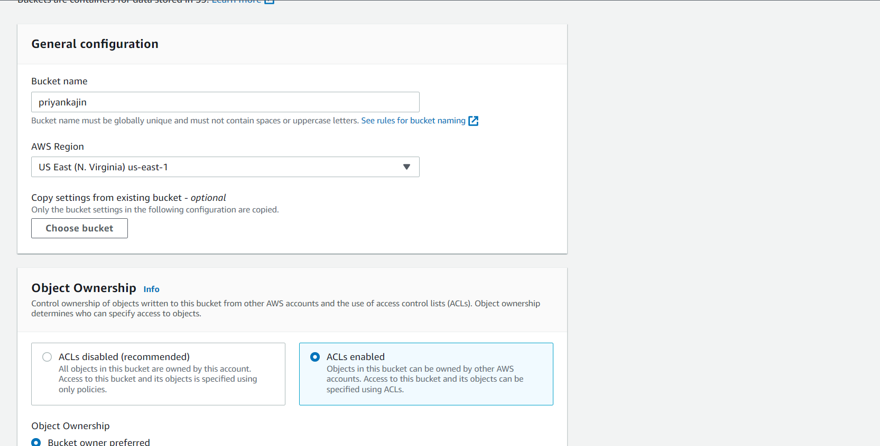

1. Under object ownership, to disable or enable ACLs and control ownership of objects uploaded in your bucket, choose one of the following settings:
2. ACLs enabled.
3. 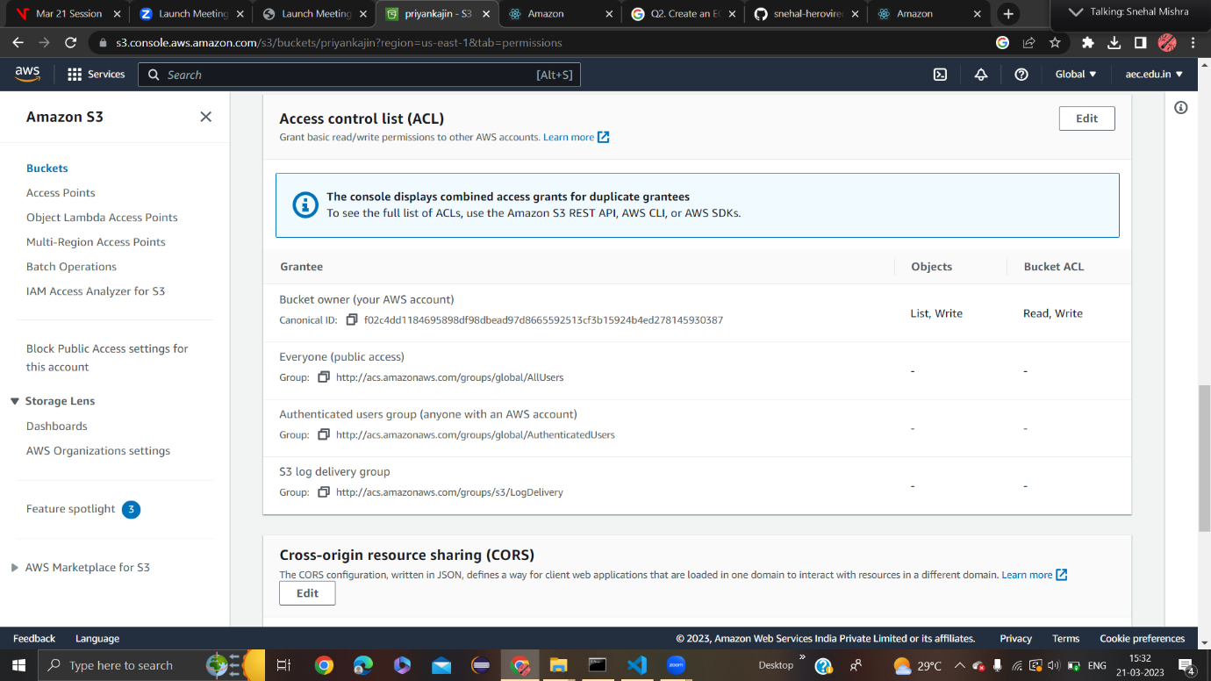
4. Under block public access settings for this bucket, choose the Block Public Access settings that you want to apply to the bucket.
5. Off the block public access and keep tick mark on the acknowledgements and save it.

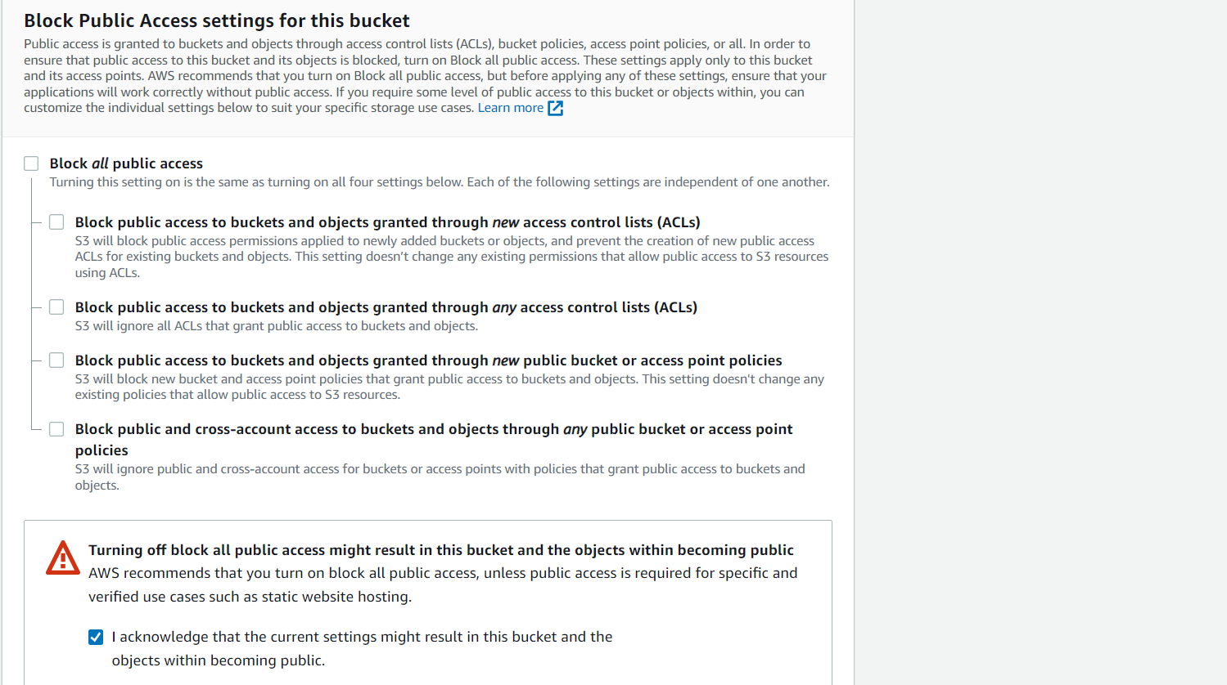

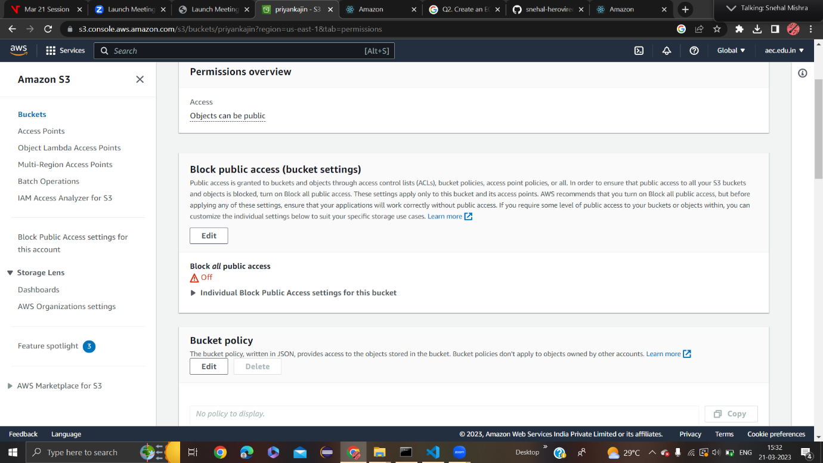

1. Create bucket after checking all the settings that we have kept or not.

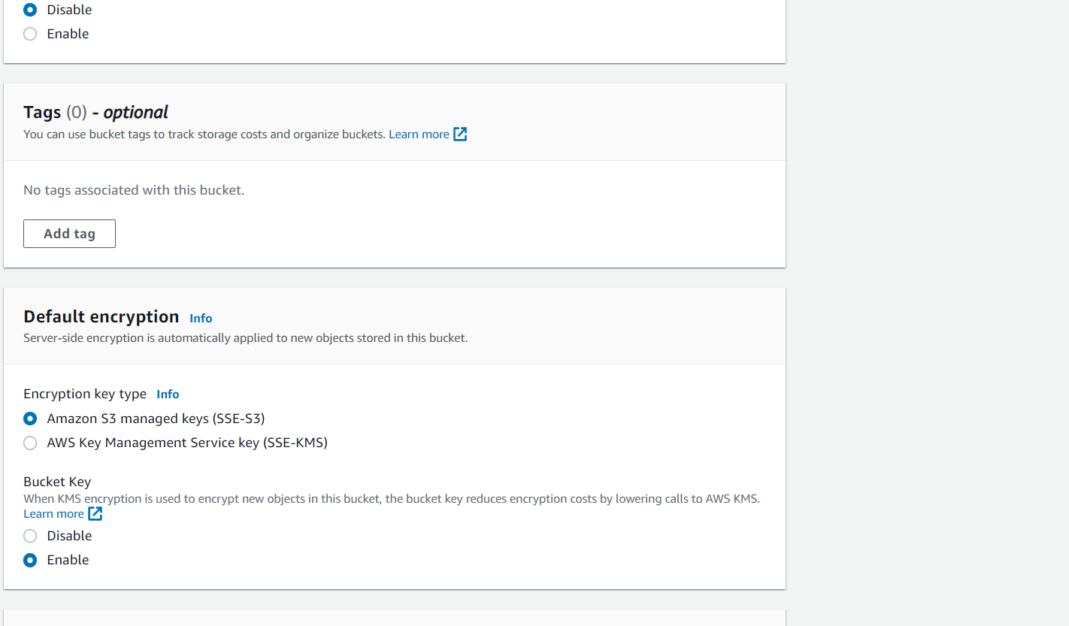

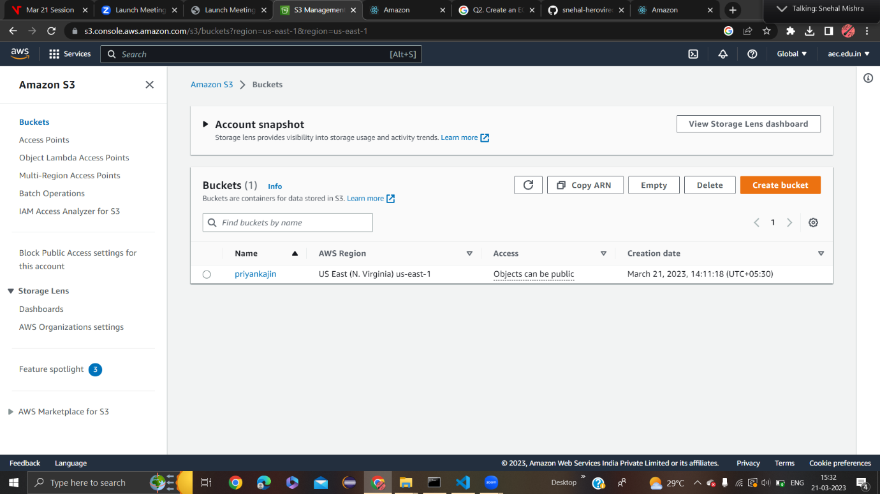

1. In the buckets list, choose the name of the bucket that you want to upload your object to.
2. On the objects tab for your bucket, choose upload.
3. In this object upload reactjs application.
4. Go to visual code.
5. Type the following commands in terminal after installing the nodejs.
6. Type ‘npm i’.
7. Type ‘npm run build’

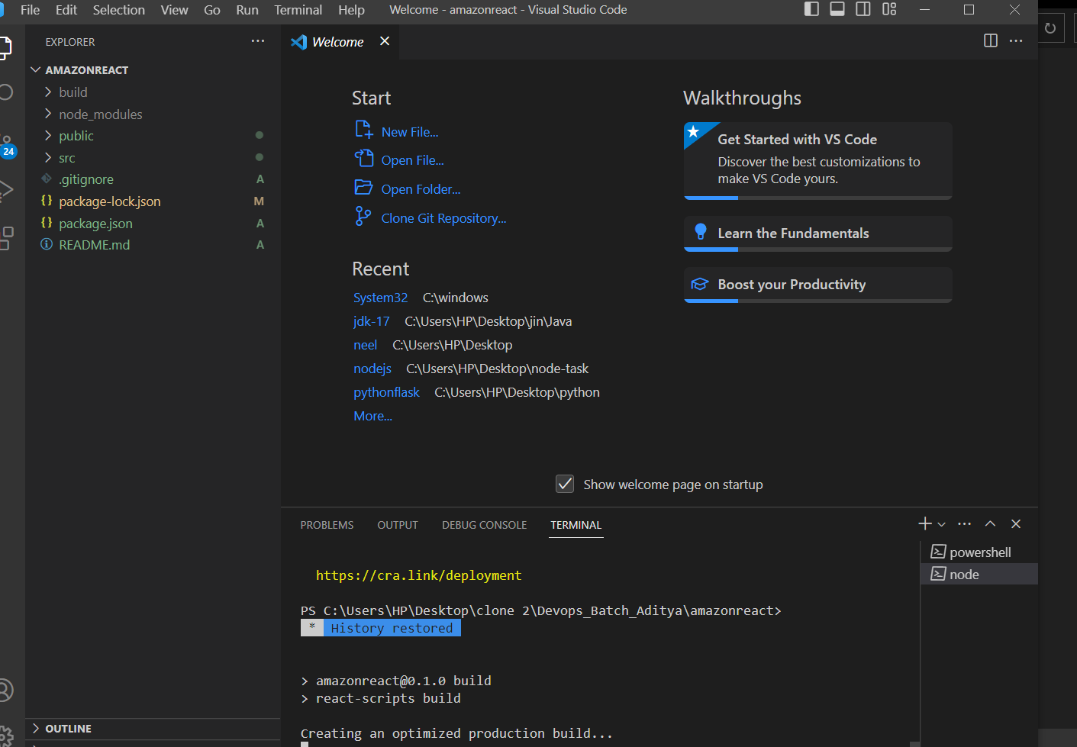

1. After running this command, a build folder appears.
2. Go to that build folder and start adding objects.

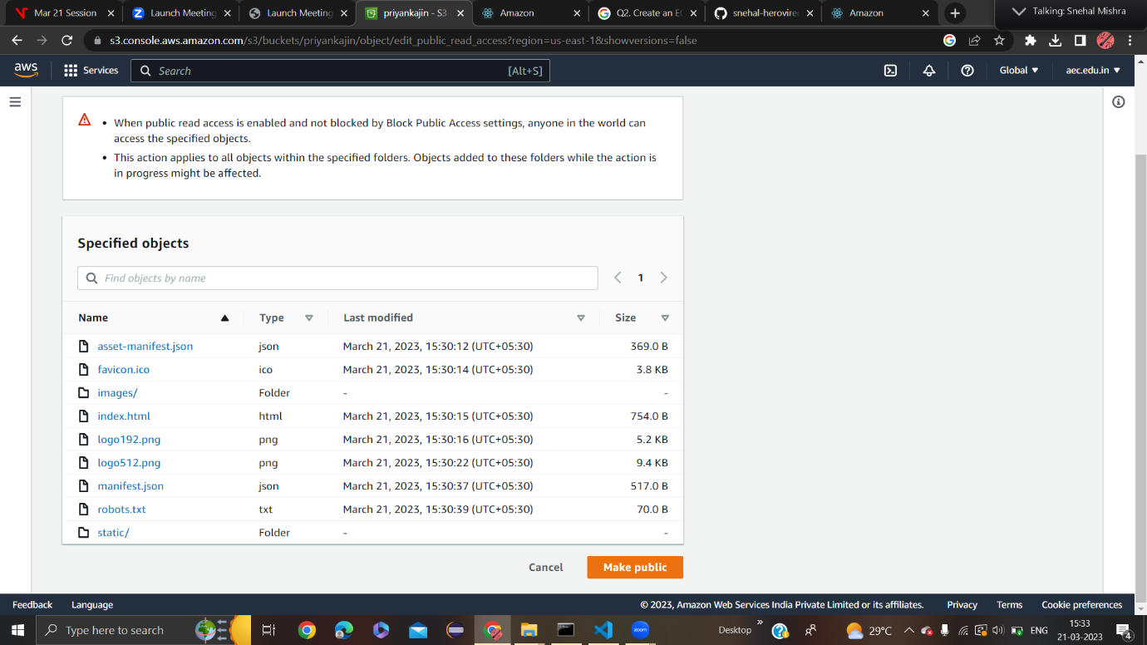

1. Under Files and Folders choose Add files.
2. Choose a file to upload, and then choose open**.**
3. Choose Upload.
4. Make the objects public to view the url.

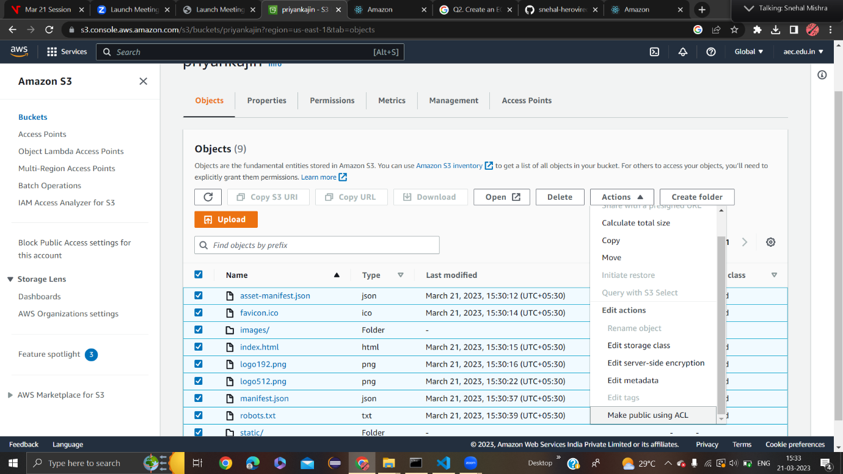

1. In the buckets list, choose the name of the bucket that you want to download an object from.
2. Go to properties.
3. Under static webhosting, choose edit.
4. Choose use this bucket to host a website.
5. Under static website hosting, choose enable.
6. Type index.html
7. Save the changes.
8. A public URL appears near static website hosting.

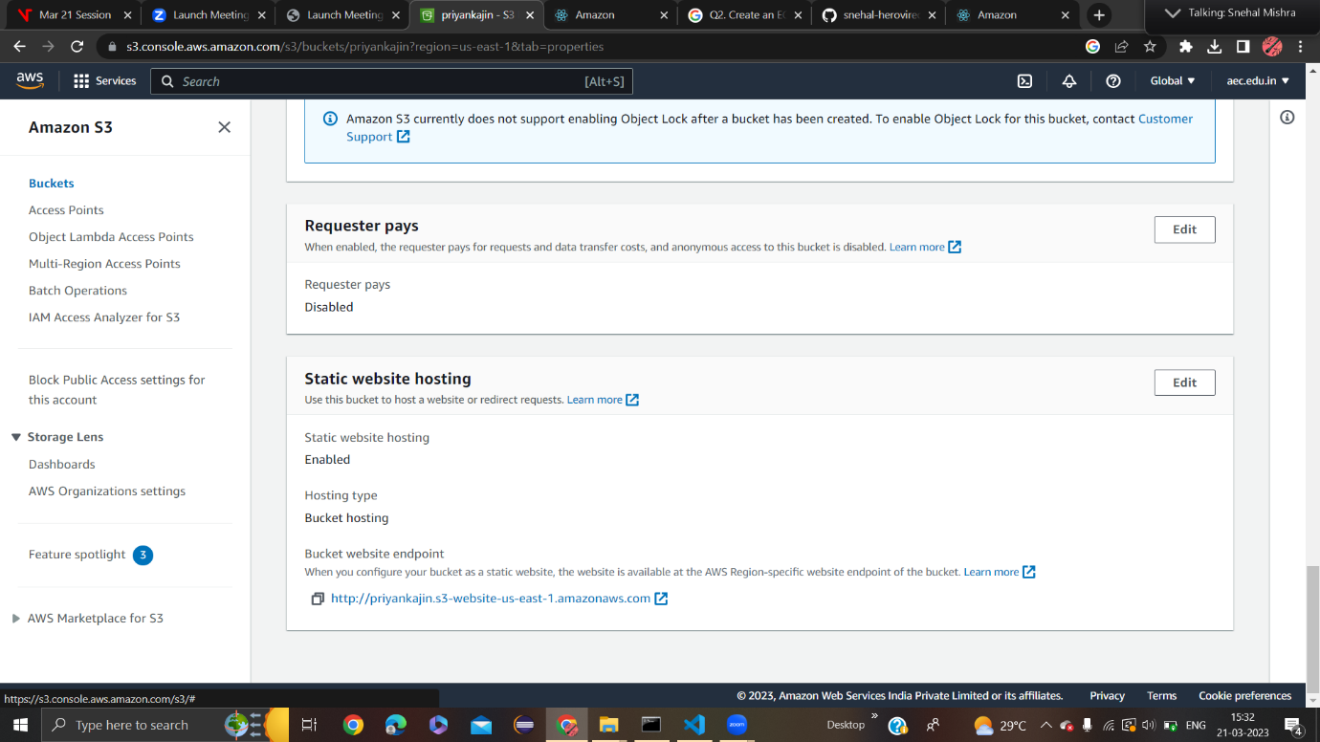

1. Open the URL in new tab.
2. Finally u will see a template or a new window.

